3. Creating a Pipeline Script

Step 1: Log in to the Jenkins Cl tool and create a pipeline script

- Open the browser, go to the Jenkins Dashboard by typing localhost:8080 in your browser, provide the credentials, and click the Sign in button
Click on the New Item option as shown in the screenshot below:

Enter a desired name for the project, select Pipeline, and then click on OK as shown in the screenshot below:

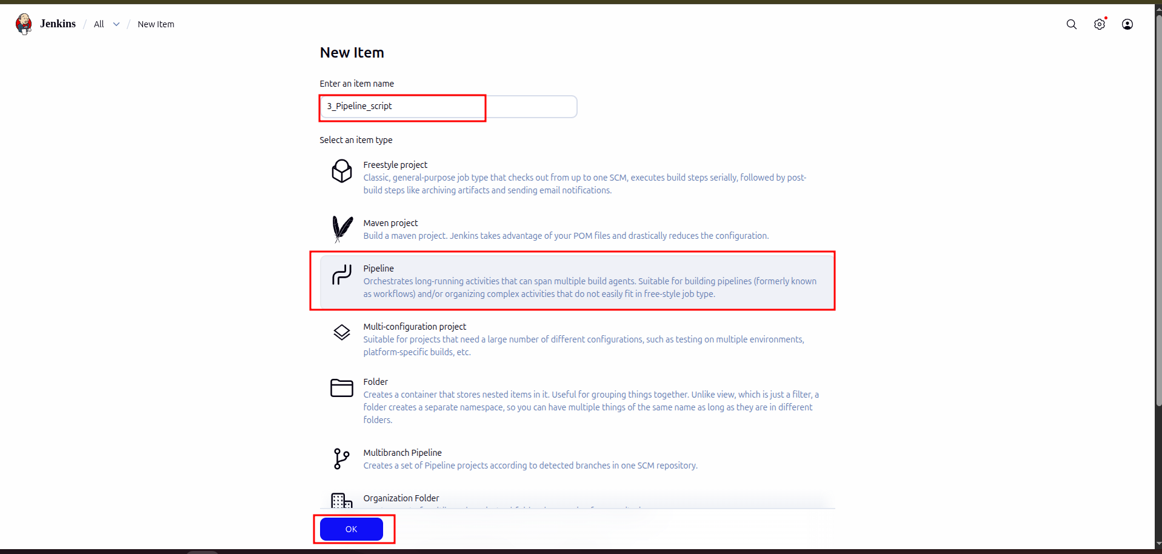

- Click on Pipeline as shown in the screenshot below:

- Enter the following pipeline script in the script editor and click on Save as shown in the screenshot below:

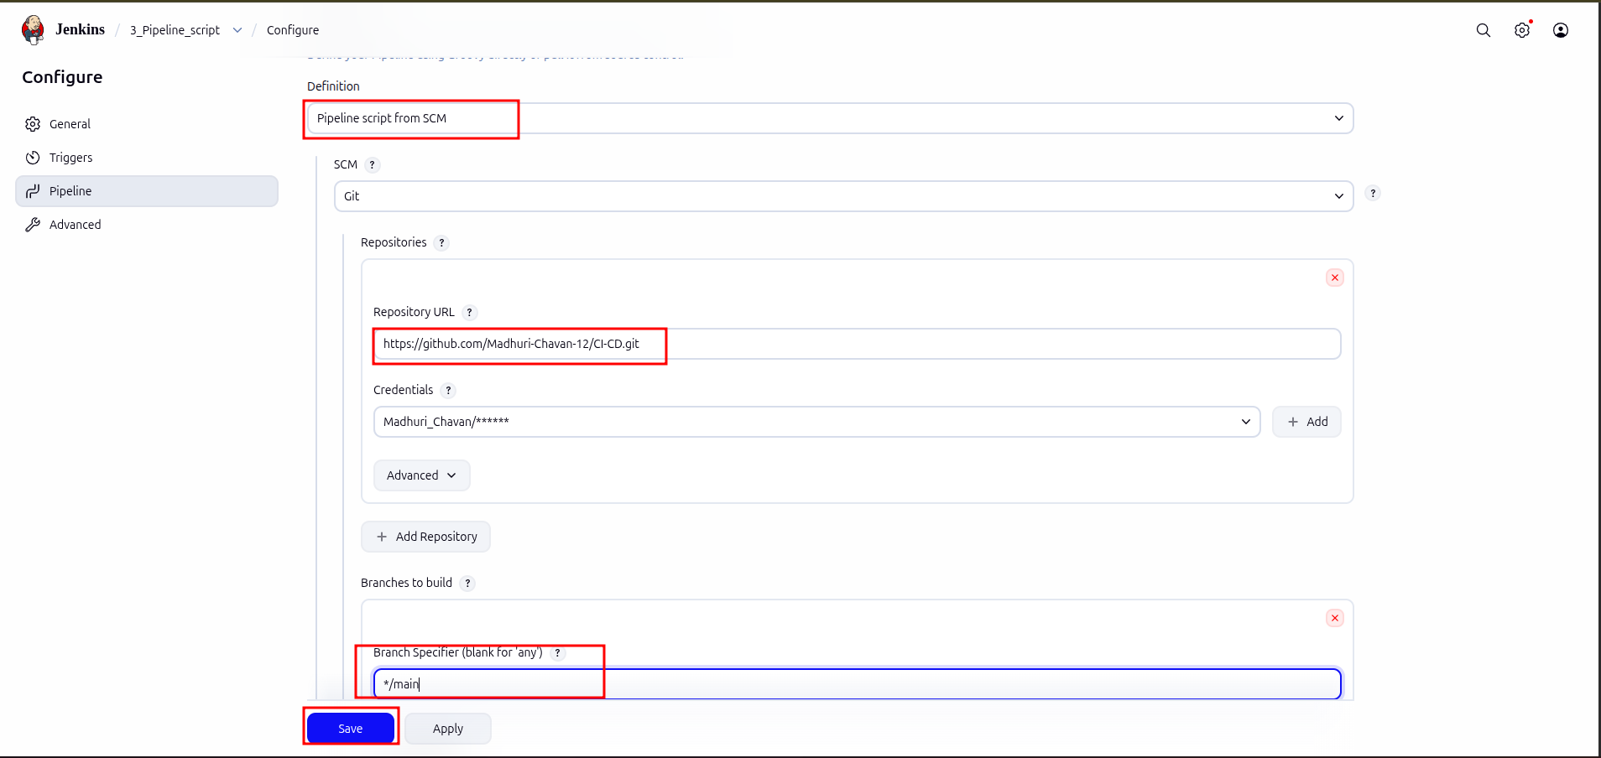

- Click on Build Now to run the pipeline script as shown in the screenshot below:

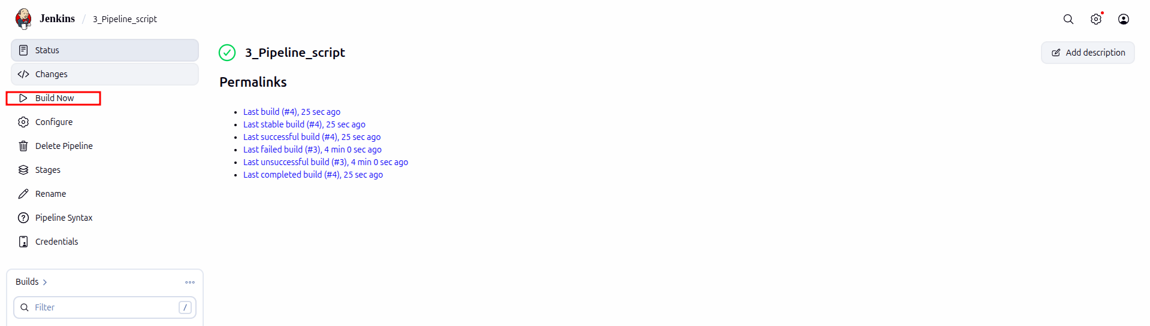

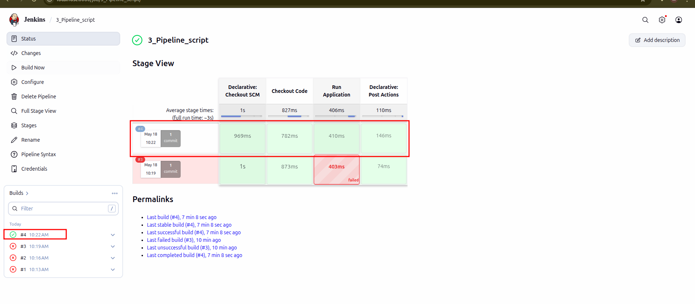

- Hover over the milliseconds number next to the build stage name as shown in the screenshot below:

Click on Logs as shown in the screenshot below:

- Check for the message in the top-left corner to confirm the successful execution of the pipeline stage as shown in the screenshot below:

